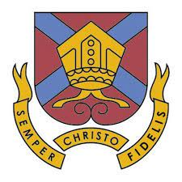

School & Community Chaplain with
The Bishop of Hereford’s Bluecoat School (BHBS)
and St Paul’s Hereford

Our Vision is to have a School & Community Chaplain who will empower and support students and staff in spiritual questions and development as part of lifelong learning – that they might discover the life in all its fulness brought by Jesus Christ (John 10:10).
We have an open door to bring the Good News of Jesus Christ to a generation almost entirely missing from our churches.
This post works collegially within a Deanery project employing 2 new full-time missional chaplains, and a growing chaplaincy presence in the city deanery, building initially over at least the next 4 years, on the huge opportunity afforded by our national CofE school vision.
We are calling these LifeLink Chaplains – making life-growing links to establish a sustainable Growing Faith in young people, and ‘LifeLink’ in two senses:
- They are to build strategic links both before and after secondary school, making creative opportunities to fan into flame the sparks of faith placed by primary school, and provide opportunities for deepening faith and discipleship that sticks going on to Further and Higher Education communities – where we are also building chaplaincy ministry.
- Our Growing Faith educational vision is built around clear evidence that real living and sustainable faith is unlikely to emerge without intentional investment in all three arenas of school, home and church life.
- St Paul’s Church have been centrally involved in the Tupsley Whitehouse Project, having established the Whitehouse Community Hub – the sole gathering place in the north half of the parish, and BHBS catchment. We see this as a key venue for creative meeting opportunities also for students, many of whom live around it.
BHBS aim through their Christian identity to empower every student to flourish in their God-given potential, developing a hunger to discover, a thirst for wisdom and grace to grow into the Life in all its fullness Jesus came to bring.

